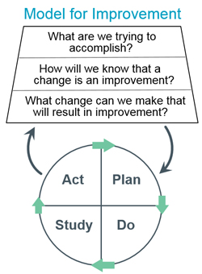
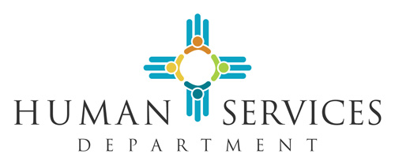

Child Support Guidelines Review Commission

Invitees
Kari Armijo, Human Services Department Deputy Secretary
Betina McCracken, Acting Division Director Child Support Enforcement Division
Jane Venohr, Ph.D., Guideline Economist
New Mexico State Senator Antoinette Sedillo Lopez
Gina DeBlassie, Office of the Governor, Health Policy Advisor
Teague González, Esq. Center for Law and Poverty
Johnny Wilson, Father’s New Mexico, Executive Director
Judge Shannon Broderick Bulman
Judge James T. Martin
Judge Jared Kallunki
Child Support Hearing Officer Stephen Klump
Wanda Martinez, Esq. Deputy General Counsel of CSED Legal Services

Meeting Agenda
Date: Tuesday, September 13 10a-12p Go to Meeting - https://meet.goto.com/545935197

Time | Agenda Item | Lead
10:00 – 10:05 | Welcome  Roll Call  Approve Agenda | Betina Gonzales McCracken
10:05-10:30 | Action Items:  - CSED Modernization Efforts  - Enforcement Action Results  - Child Support Payment Sources  - Actual Hours Worked – National and Local Data | Betina Gonzales McCracken
10:30-11:15 | Impact of Incorporating the Self Support Reserve (SSR) | Betina & Jane Venohr, Ph.D
11:15 – 11:30 | Public Input | Jill Goodmacher
11:30 – 11:55 | Commission Decision Items & Next Steps | Commission
11:55 – 12:00 | HSD Potential Legislation | Kari Armijo
12:00 | Adjourn

